igus roller e-chain for targeted irrigation with savings potential
New precision irrigation carriage reduces water and fertiliser consumption by 75% - e-chain in a trough guides hoses with additional energy saving

The aim of the precision irrigation carriage from Rathmakers Gartenbautechnik is to use water resources sensibly whilst protecting the groundwater at the same time. With the new automatic irrigation system, the water reaches exactly where it should: directly to the plants. For the safe and compact guidance of hoses and cables, the developers rely on an igus energy chain system consisting of roller chain and guide trough.

Water shortage is a major problem worldwide, which is why solutions are needed, especially in agriculture, which bring water in a targeted manner to the plant. For this purpose, Rathmakers Gartenbautechnik has developed a precision irrigation carriage together with Landwirtschaftskammer NRW. Whereas conventional irrigation carriages with a continuous jet stream waste a lot of water, the precision watering carriage irrigates and fertilises in a stipulated way. The unique system is especially suitable for outdoor potted plant cultivation and ensures that water is delivered precisely into the middle of the plant's growing pot. By using this new technology, savings of 50 to 75 per cent are possible in irrigation water, plant protection and fertiliser, depending on the pot size. This also reduces the nitrogen input into the groundwater. The precision irrigation carriage has a span of 40m and a travel of 208m. The cables and hoses for the water supply were pulled behind the carriages until now. A loop was created, which required about 2m of space between the carriage guide and the plants. A safe and space-saving hose with cable guidance was required. Therefore, Ralf Hormes, CEO at Rathmakers Gartenbautechnik, contacted igus. "Together with the igus experts, we decided to design a roller energy chain in a guide trough", explains Ralf Hormes.

343 sqm of more usable space
The main advantage of the system: by guiding the hoses and cables, the usable area is increased by 343 square metres. It also increases the service life of the supply components in the system. A 3500R series roller chain with a width of only 35cm is used in a guidelite guide trough. The technical basis of the energy chain is the integration of rollers into the chain links to reduce the coefficient of friction on long travels. Thereby, up to 57 per cent of the required drive energy can be saved while moving the energy chain system. The guidelite guide trough is a cost-effective and quickly installable solution made of corrosion-resistant and durable high-performance polymer. "An all-round system that has proven itself technically and also from a cost perspective", says Hormes. Since November 2019, igus has taken back plastic energy chains and troughs when the system has reached the end of its service life and guarantees segregated recycling. In return, the user receives a credit note based on the net weight.

Caption:

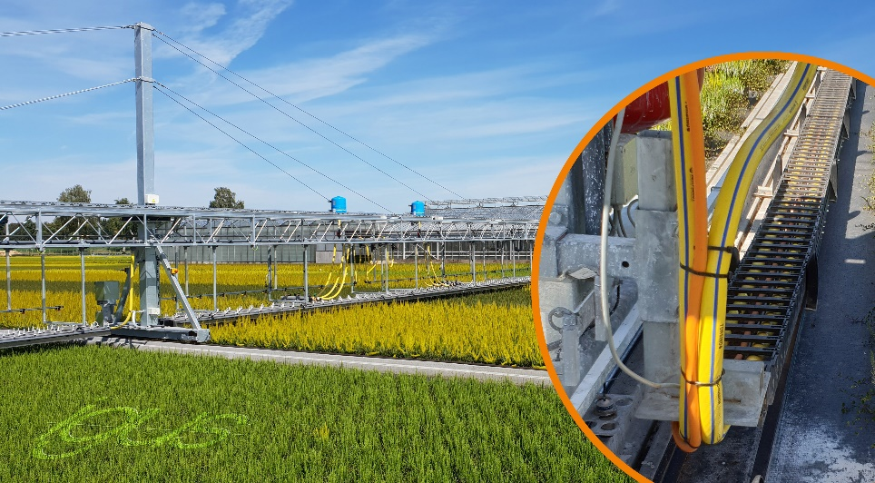
Picture PM4220-1
A roller energy chain in a guidelite guide trough ensures safe guidance of the hoses and cables in the precision irrigation carriage. (Source: igus GmbH)

PRESS CONTACT:  Harish Bhooshanan  Product Manager  E-ChainSystems®  igus (India) Private Limited  36/1, Sy. No. 17/3  Euro School Road,  Dodda Nekkundi Industrial Area - 2nd Stage  Mahadevapura Post  Bangalore - 560048  Phone : +91-80-49127809 (Direct)  Harish@igus.in  Visit us on www.igus.in | ABOUT IGUS:  igus GmbH develops and produces motion plastics. These lubrication-free, high-performance polymers improve technology and reduce costs wherever things move. In energy supplies, highly flexible cables, plain and linear bearings as well as lead screw technology made of tribo-polymers, igus is the worldwide market leader. The family-run company based in Cologne, Germany, is represented in 35 countries and employs 3,800 people across the globe. In 2019, igus generated a turnover of €764 million. Research in the industry's largest test laboratories constantly yields innovations and more security for users. 234,000 articles are available from stock and the service life can be calculated online. In recent years, the company has expanded by creating internal startups, e.g. for ball bearings, robot drives, 3D printing, the RBTX platform for Lean Robotics and intelligent "smart plastics" for Industry 4.0. Among the most important environmental investments are the "chainge" programme – recycling of used e-chains - and the participation in an enterprise that produces oil from plastic waste. (Plastic2Oil).

The terms "igus", “Apiro”, "chainflex", "CFRIP", "conprotect", "CTD", “drygear”, "drylin", "dry-tech", "dryspin", "easy chain", "e-chain", "e-chain-systems", "e-ketten", "e-kettensysteme", "e-skin", “e-spool”, "flizz", “igear”, "iglidur", "igubal", “kineKIT”, "manus", "motion plastics", "pikchain", "plastics for longer life", "readychain", "readycable", “ReBeL”, "speedigus", "tribofilament“, "triflex", "robolink", and "xiros" are protected by trademark laws in the Federal Republic of Germany and internationally, where applicable.

