Surfing on tarmac with wear-resistant plain bearings from igus
iglidur Z and iglidur J350 high-performance plastics ensure safe bearings in an innovative skateboard

The Curfboard is a new type of sports equipment that combines a surfboard and a skateboard and in the process, has to withstand extreme loads. Especially high are the demands on its moving components, including the bearings. These must be wear-resistant, resilient, maintenance-free and reliable even under the toughest "Curf" conditions. Therefore, the developers at the curfboard GmbH rely on wear-resistant plain bearings made of iglidur Z and iglidur J350 high-performance polymers from igus.

Whether skating or surfing, the curfboard from curfboard GmbH combines the two sports in a new sports and leisure equipment. So the manufacturer promises "the ultimate surf-ride feeling on wheels". Ensured by the new, special axes. They do without any rubber dampers or springs and have a 4-joint kinematics, which makes them self-regulating. Gravity assists the automatic adjustment to the weight of the rider. In addition, the board has a better response behaviour, making it easier to control. Another special feature is that the rider no longer has to push off to move. Instead, similar to surfing, speed is built up by shifting the body's weight – and even uphill. The demands on the components are therefore particularly high. While the skateboard stresses the axles and the bearings particularly when cornering, the curfboard is exposed to stress all the time. To withstand these stresses, Stephan Augustin, the inventor of the Curfboard, chose wear-resistant plain bearings made of iglidur Z and iglidur J350 high-performance polymers.

iglidur Z and iglidur J350 plain bearings pass the hardness test
In search of the appropriate plain bearings, Stephan Augustin initially carried out a four-month outdoor test under the harshest conditions with bearings from various manufacturers. "After evaluating the test results, it became apparent that only the igus plain bearings made of iglidur Z and iglidur J350 met the requirements," explains Stephan Augustin. Whereas metal/PTFE composite plain bearings wore out after a short time and completely failed, the iglidur plain bearings of the motion plastics specialist were able to prove themselves. Since the plain bearings had to be abrasion-resistant and at the same time corrosion-free and maintenance-free despite the permanent high loads, the manufacturer chose the high-performance plastic iglidur Z for the bearings directly on the boom. The material is characterised by its wear resistance and insensitivity to edge pressure. Plain bearings made of iglidur J350 are used at less stressed points. The material is very convincing due to its low coefficient of friction on steel and aluminium and is insensitive to shocks and impacts. Another advantage is the lubrication-free iglidur bearings, so that no dirt can adhere to the bearings. In addition, both materials – like all iglidur plain bearing materials – do not require any lubrication. Thanks to the solid lubricants embedded in the plastic, the bearing remains completely dry. Dirt and dust cannot easily adhere and are easy to wash off.

www.curfboard.com

The Curfboard in action: https://www.youtube.com/watch?v=3nAgzanaCXA

Caption:

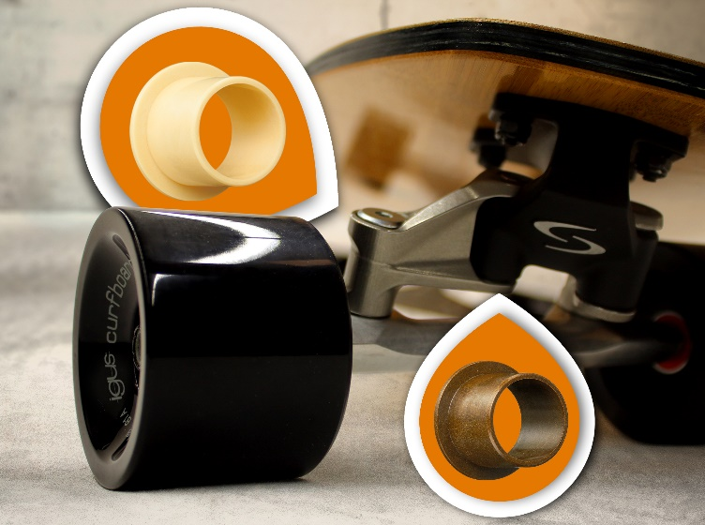
Picture PM3419-1
Plain bearings made of the wear-resistant high-performance polymers iglidur J350 and iglidur Z ensure trouble-free ride on the Curfboard even with heavy load. (Source: igus GmbH)

PRESS CONTACT:  Nitin Prakash  Product Manager  iglidur®  igus (India) Private Limited  36/1, Sy. No. 17/3  Euro School Road,  Dodda Nekkundi Industrial Area - 2nd Stage  Mahadevapura Post  Bangalore - 560048  Phone : +91 7760368383  nitin@igus.in  Visit us on www.igus.in | ABOUT IGUS:  igus GmbH is a globally leading manufacturer of energy chain systems and polymer plain bearings. The Cologne-based family business has offices in 35 countries and employs around 4,150 people around the world. In 2018, igus generated a turnover of 748 million euros with motion plastics, plastic components for moving applications. igus operates the largest test laboratories and factories in its sector to offer customers quick turnaround times on innovative products and solutions tailored to their needs.

The terms "igus", “Apiro”, "chainflex", "CFRIP", "conprotect", "CTD", "drylin", "dry-tech", "dryspin", "easy chain", "e-chain", "e-chain-systems", "e-ketten", "e-kettensysteme", "e-skin", "flizz", “igear”, "iglidur", "igubal", “kineKIT”, "manus", "motion plastics", "pikchain", "plastics for longer life", "readychain", "readycable", “ReBeL”, "speedigus", "triflex", "robolink", and "xiros" are protected by trademark laws in the Federal Republic of Germany and internationally, where applicable.

